28 to 24 pin kernal ROM adapter and switcher for C64 longboard

User Guide
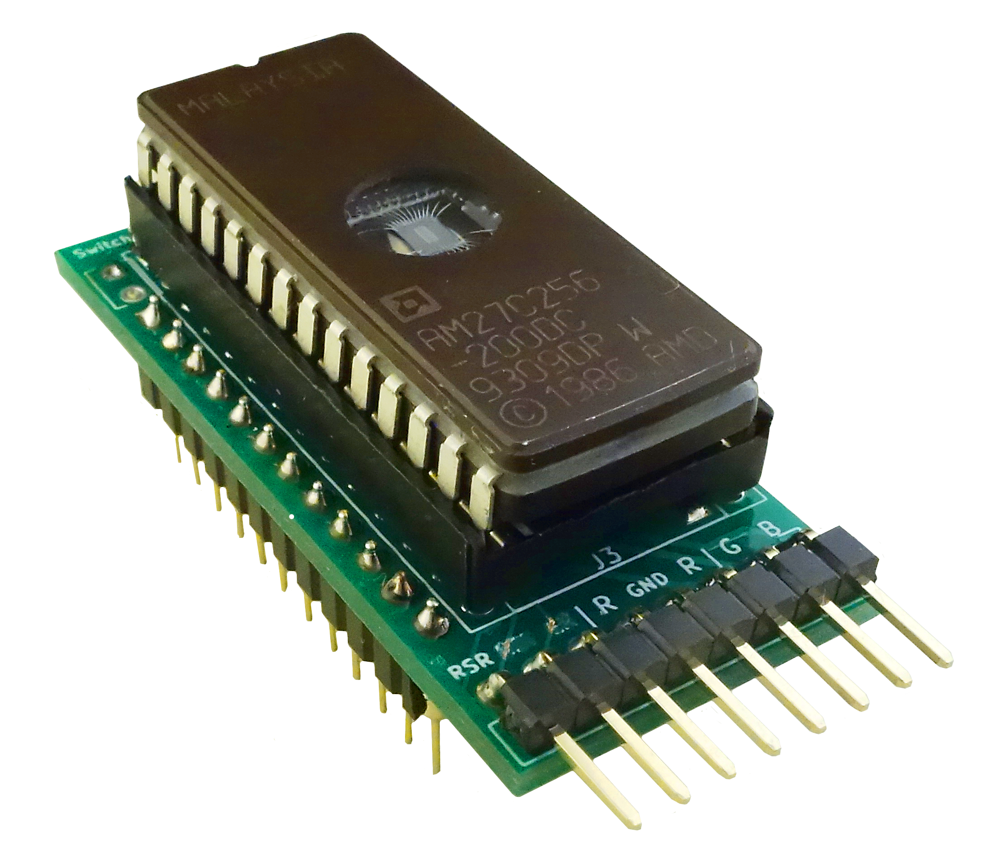

Introduction
Maybe you just need a 24-28 adapter, or you want 4 or 8 kernals in one chip. The Switchless Kernal Switcher (SKS64) is just what you need. There are two boards, one for long motherboards, and one for short.

Board overview

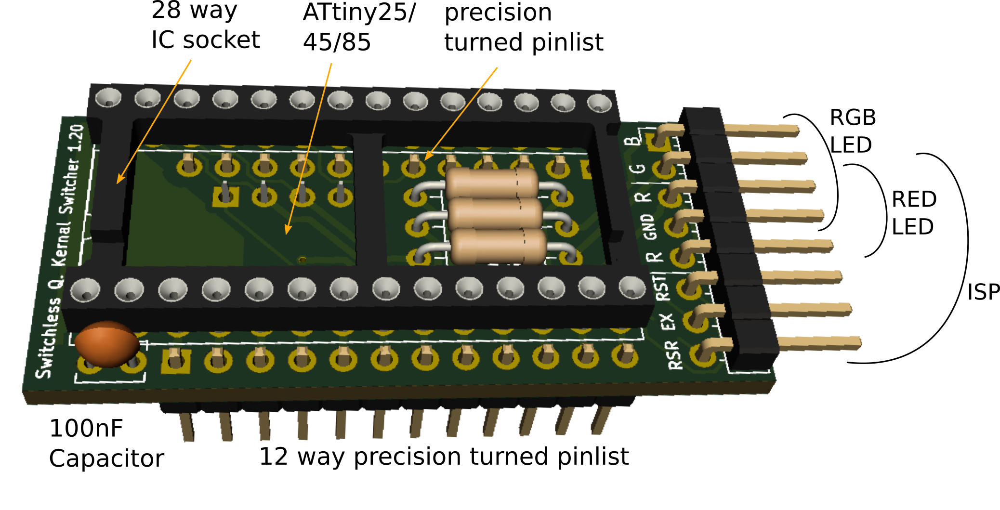
Switching Kernals
The selection mode is entered by holding RESTORE for two seconds, and is indicated with a slight flash of RED on the RGB LED. Be quick and continue to tap RESTORE until the desired colour on the LED is shown. The computer reset after two seconds of no activity.
The timing can be changed in the source code:
#define PRESSTIME 20
#define MENUTIMEOUT 20
The RESTORE key still works as a normal for short presses. The C64 cannot read long RESTORE key presses anyway.

RESET
Hold the RESTORE key for two seconds. Wait two seconds for the reset.

EXROM RESET
Hold the RESTORE key for five seconds. Some machine language programs change the way the computer returns after a reset. In that case the only way to reset to basic is to turn the machine off. By controlling both RESET and EXROM it is possible to "cold start" the machine. Note: EXROM reset is only available when the ATtiny's RESET pin is disabled (fuse bit #RSTDISBL). This can only be done with HV-programmers (like TL866).

Board Assembly
Because the board is so convoluted, the components need to be soldered in a special order to be able to reach all the solder pads. Start with the smallest parts first: R1, R2, R3, C1, and U1. (U2 also inshortboard). Solder the IC sockets and pinlists in the order shown below to save time. Finally solder the right angle pin header J4.
1
4

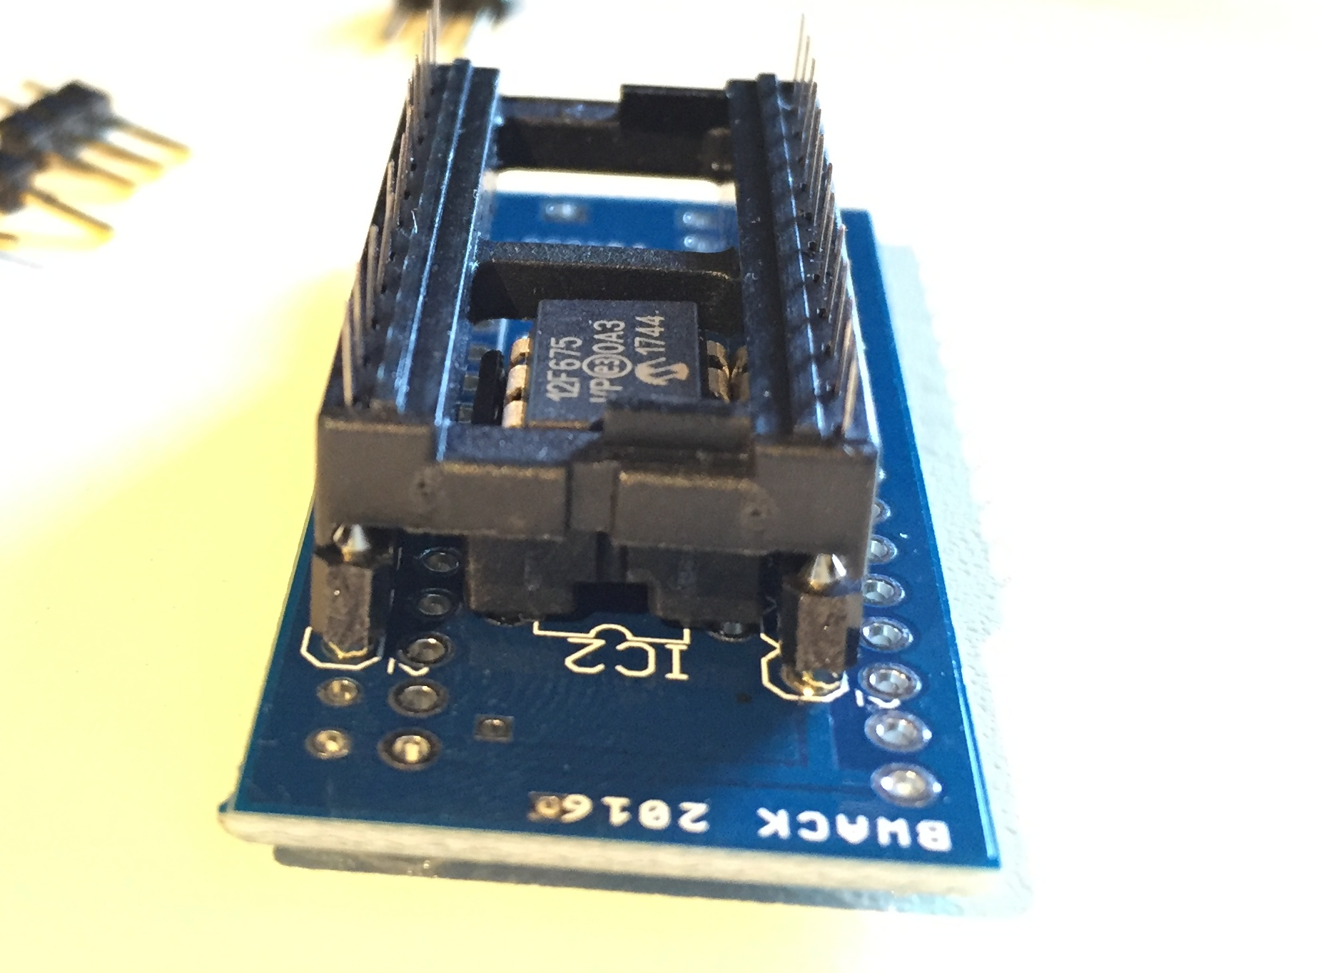
Soldering order:
- 1. Solder U1 8pin IC Socket
- 2. Solder J2 bottom left pinlist
- 3. Flush cut soldering on top side
- 4. Solder J3 28pin IC Socket
- 5 Insert the last pinlist into a dummy IC socket, and place the adapter into the socket.
- 6. Solder J1 top left pinlist
- 7. Solder J4

2
6
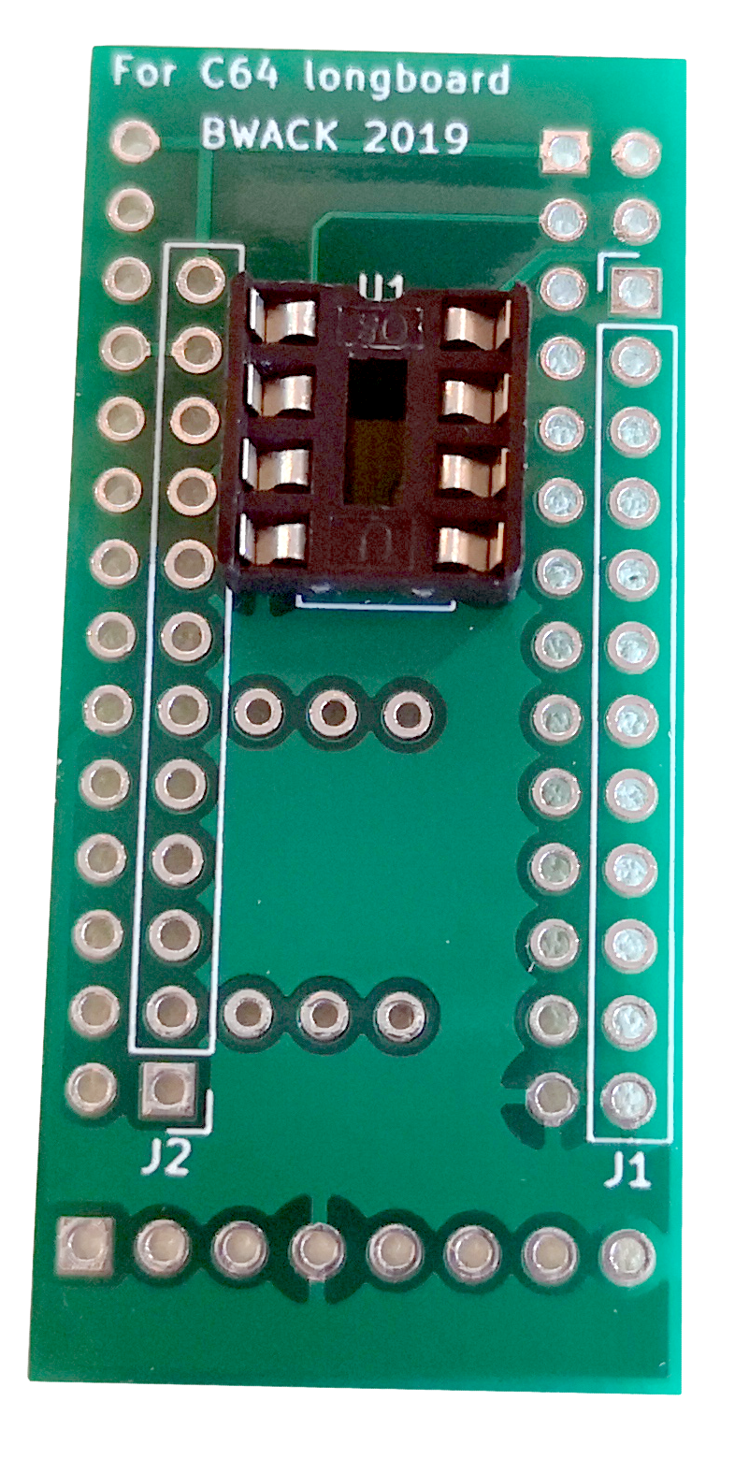
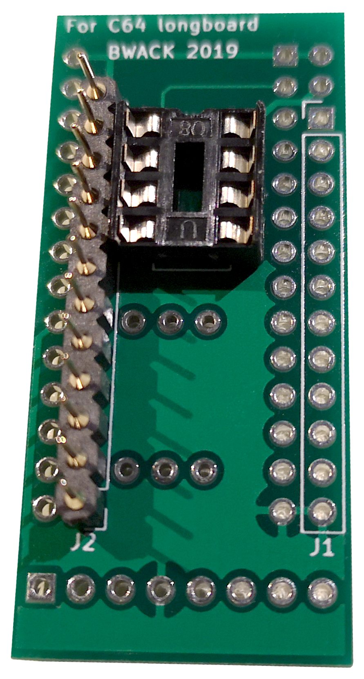
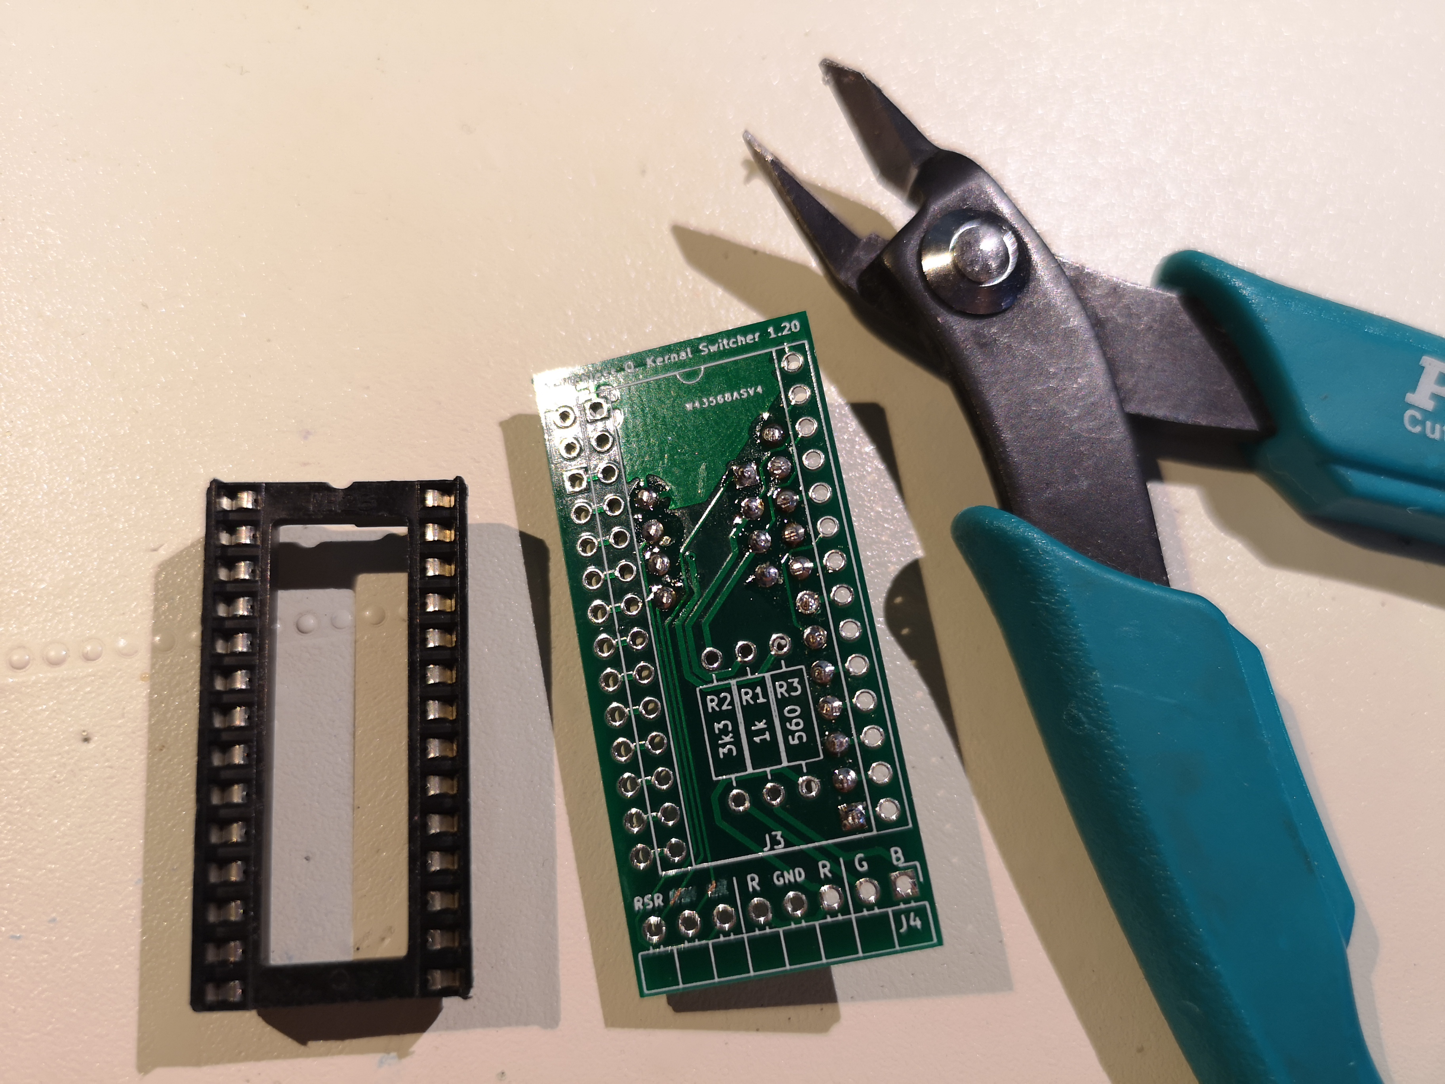
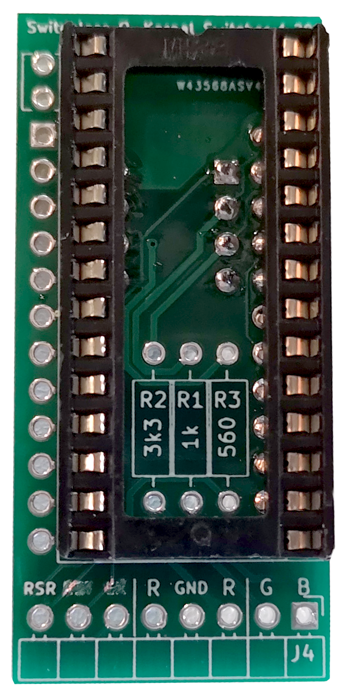
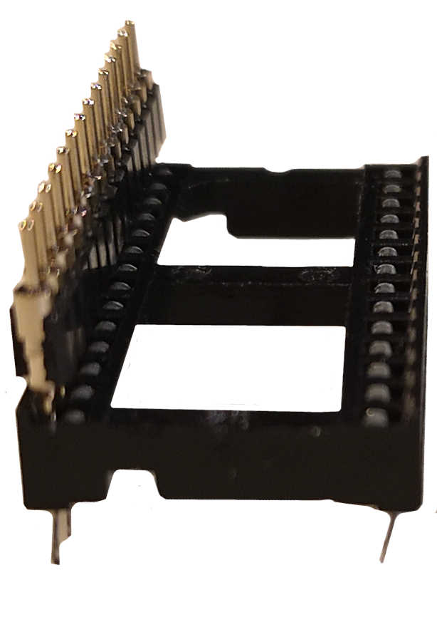
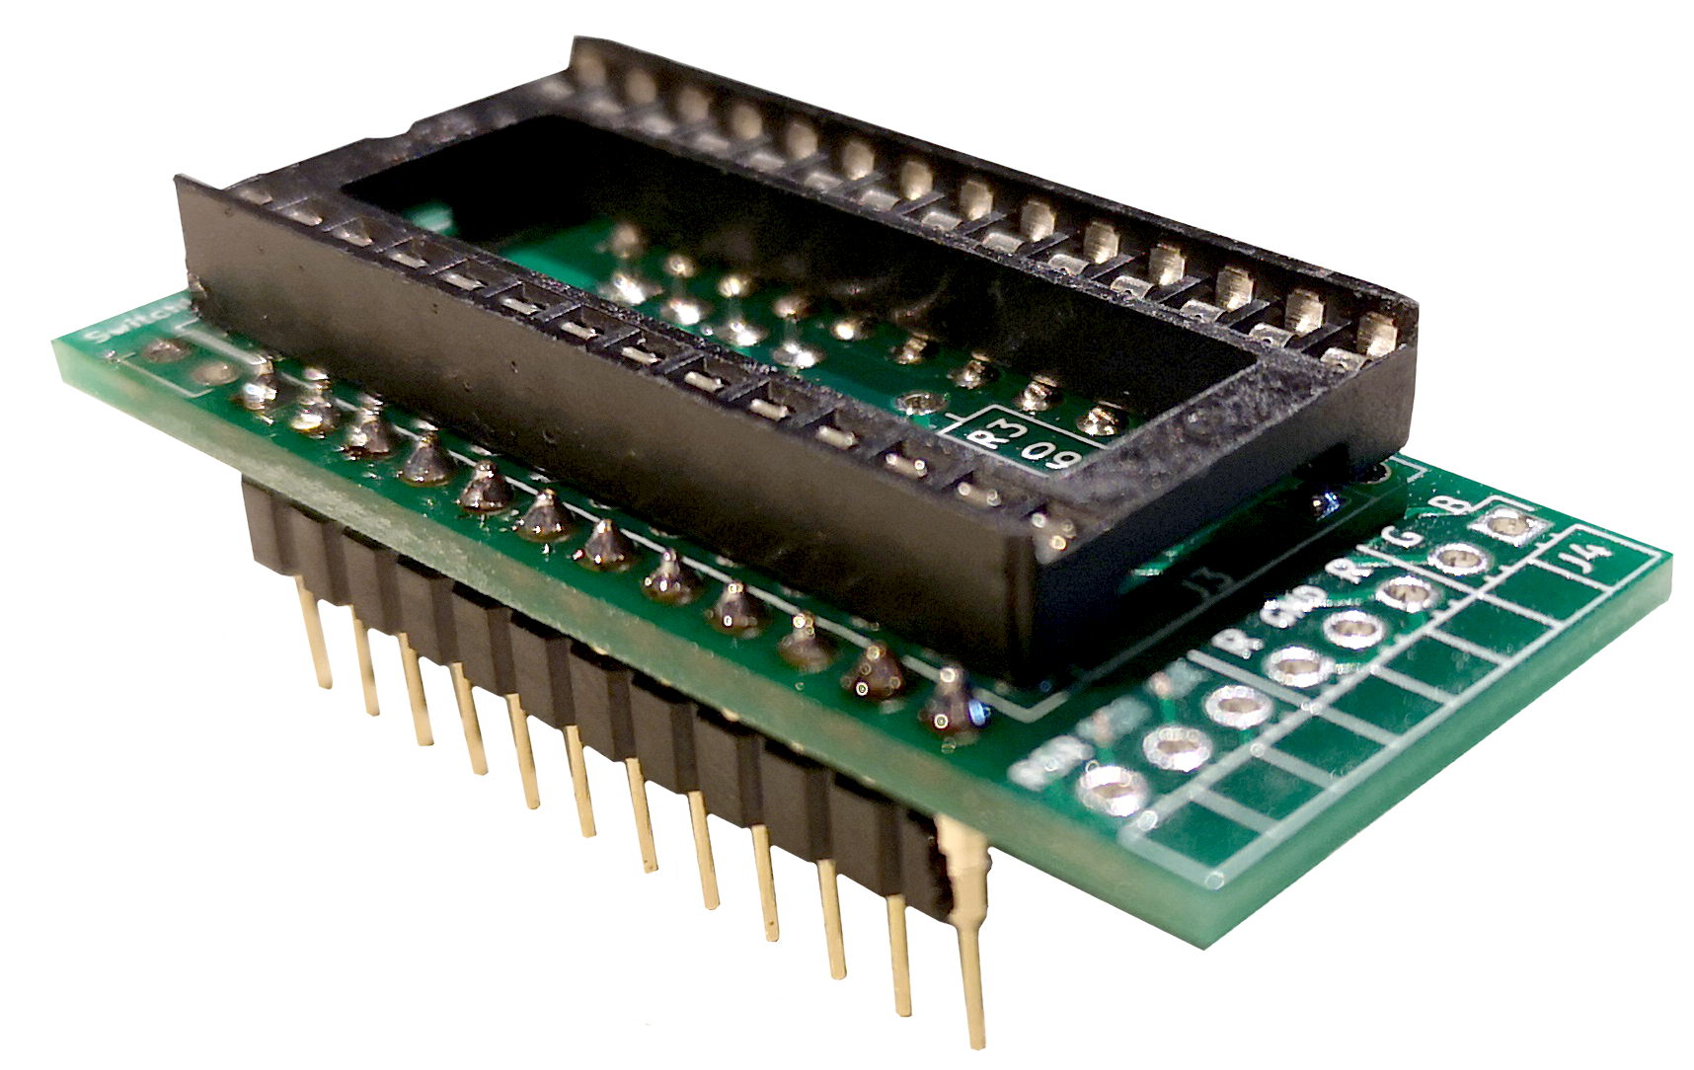
1
2
3
4
5
6

Installation and Wiring
Desolder the KERNAL IC and replace it with an IC socket or precision turned socket lists. Pin headers should fit into the C64 vias connected to RESTORE, RESET and EXROM. The via locations varies between the motherboard revisions.
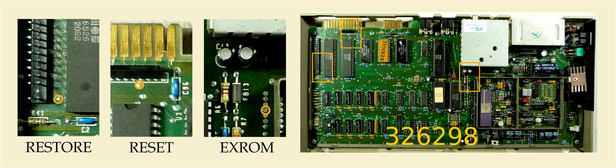
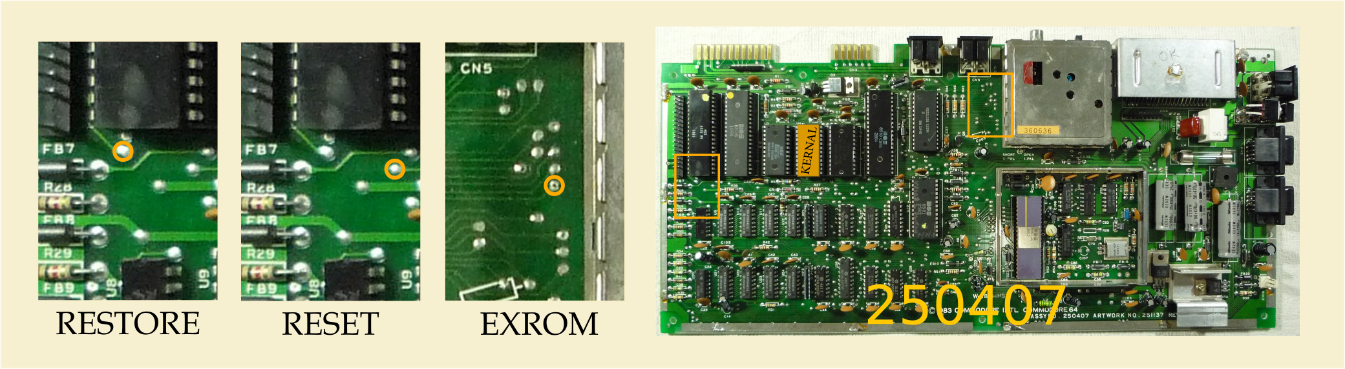
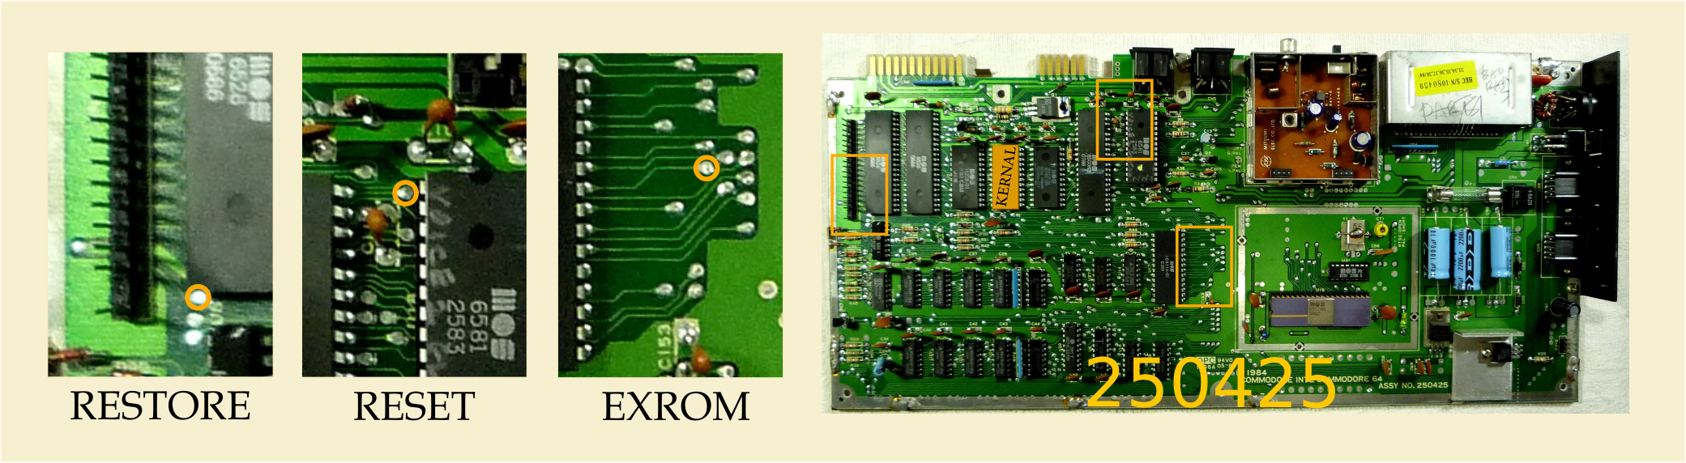
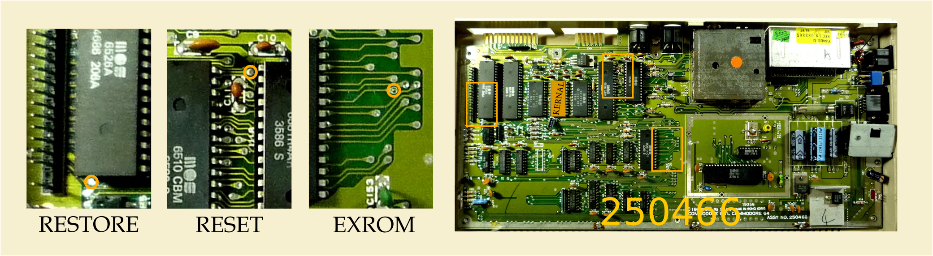

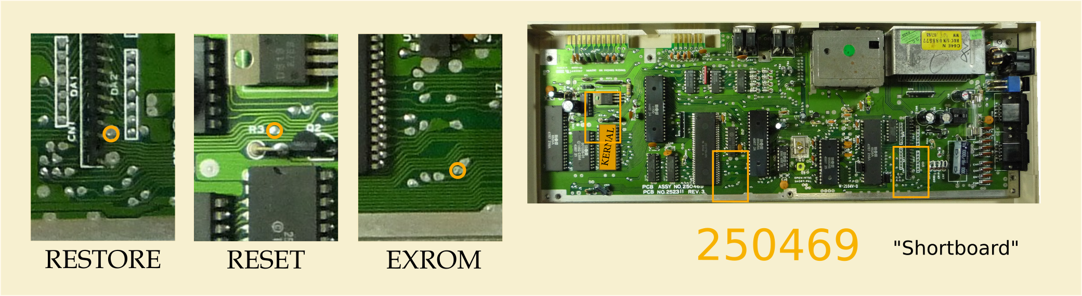
Programming
The microcontroller used is Attiny25/45/85. This enables Arduino development workflow. To work with the Arduino IDE you need to install the ATtinyCore libraries.

Arduino as ISP
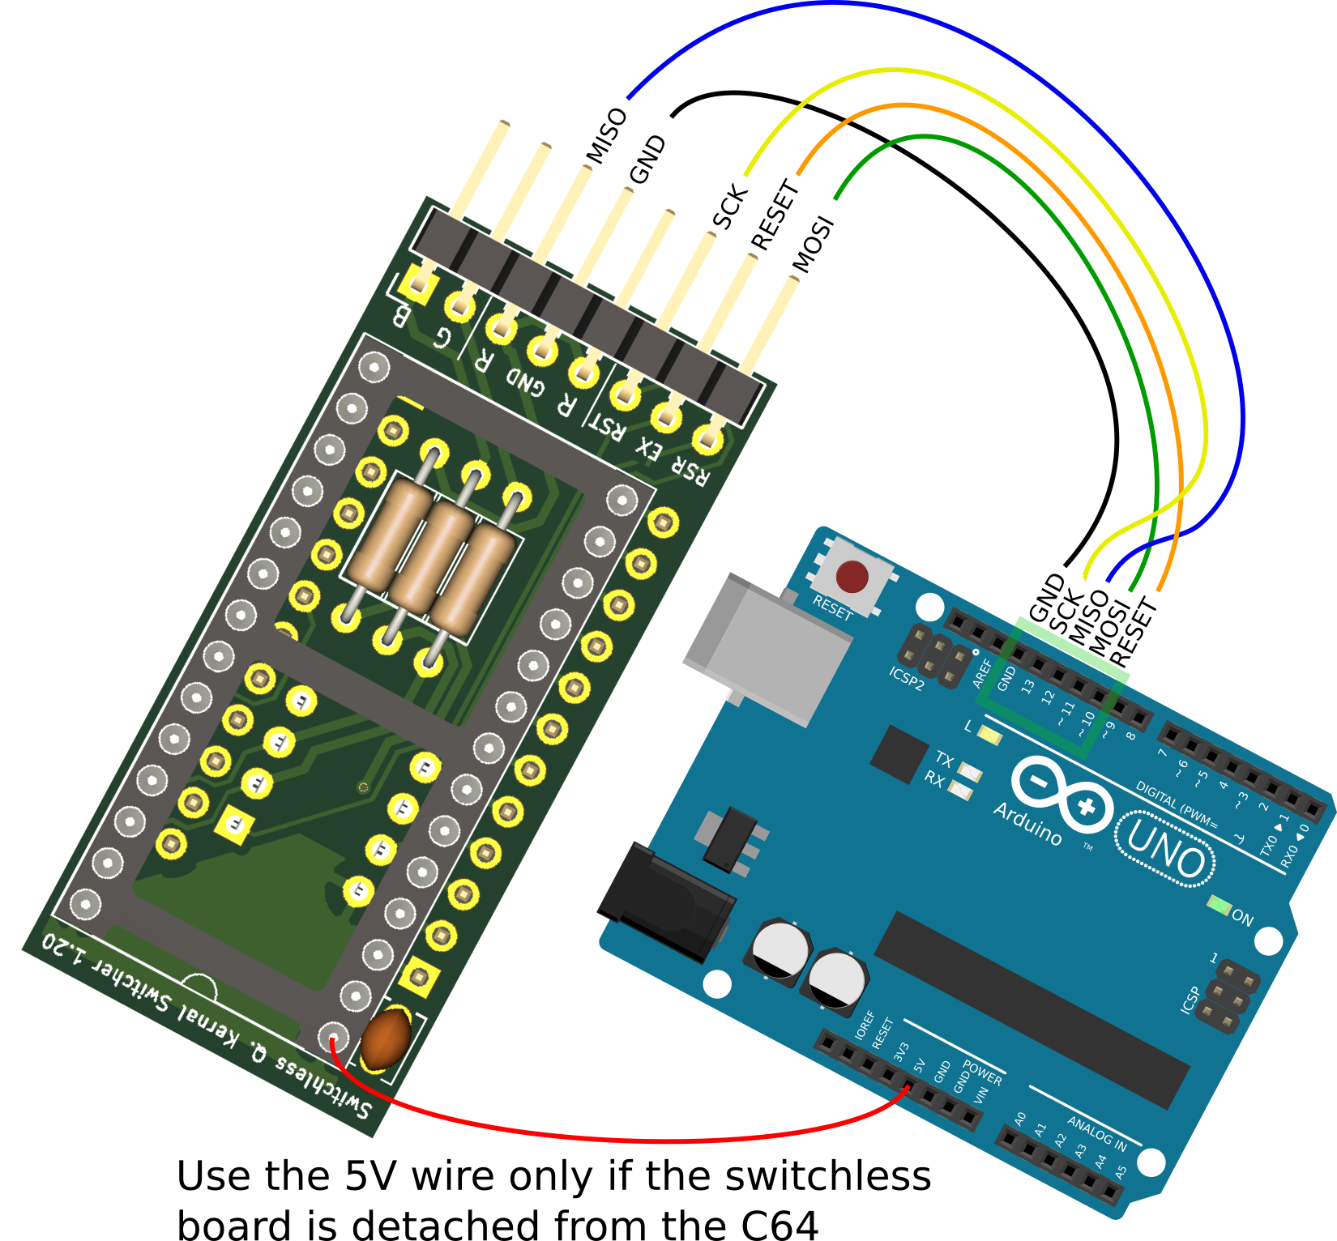
Upload the ArduinoISP sketch to your Arduino UNO. It is located in the Arduino IDE in the drop down menu File/ Examples/ 11.ArduinoISP/ ArduinoISP. Open the SKS64_SKETCH.ino file, and select: Board ATtiny25/45/85. Processor ATtiny85, and Clock Internal 1 MHz, Programmer Arduino as ISP. Connect all cables. If you power the SKS64 with Arduino 5V, you must not connect the SKS64 to the C64. Click Burn Bootloader ! This will write to the fuse bits, and there is no Arduino bootloader for the ATtiny family. Finally click upload sketch! The firmware gives a long flash and two short flashes on the RED LED if the fuse bits wasn't programmed.

USBasp as ISP
Similar workflow as Arduino as ISP. Select programmer: USBasp.

High Voltage programmer
The MCU must be popped out of the SKS64 and into the ZIF socket if using a HV programmer like for example a TL866CS/A. The programmer is loaded with the “hex-file”, and fuse bits are set. Unlike ISP programmers, HV programmers do not need MCU RESET. Activating #DISBLRST in the fuse bits will free up the last I/O of the ATtiny. The downside of #DISBLRST is that if you intend to further develop the firmware and program using ISP, you will need to use the HV programmer first to re-enable RESET!
The hex-file can be found in the output of the Arduino IDE. Turn on File/Preferences → Settings → Show Verbose output durring: “compilation” and “upload”. Click compile. and look for the line that says something like: “C:\Users\hada\AppData\Local\Temp\arduino_build_581768”. Here you will find the hex-file.
Note: At power on, the SKS64 firmware reads the #DISBLRST fuse bit. If reset is disabled, the firmware will drive the EXROM signal. If reset IS enabled, the EXROM reset feature is disabled.
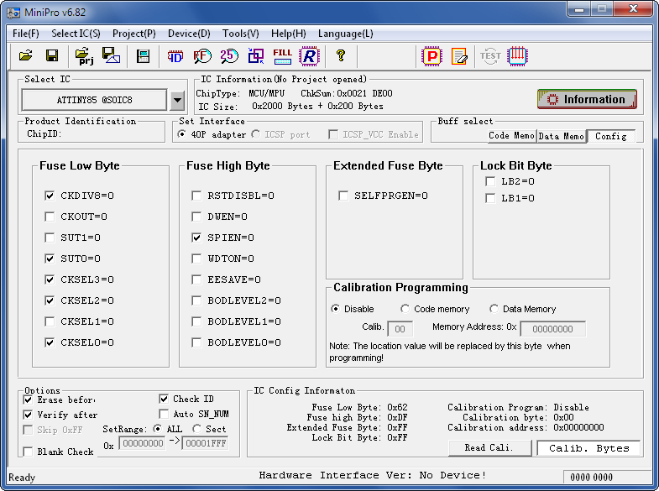
Make sure that Fuse Low Byte, high byte are 0x62 and 0xDF if reset is enabled, or 0x62 and 0x5F if disabled.
Pitfall: In MiniPro if you are in the Config window like above, and you try to load a hex file with File/Open, you will get an error message, but the fuse bits will be mangled. Writing the wrong fuse bits can lock you out of an ISP programmer.

Setup
After installing the firmware in the SKS64, and installing it in the computer you can enter the setup menu by holding RESTORE while powering on the machine. Continue to hold RESTORE until the LED flashes white. Tap RESTORE to rotate through all the four possible setups. Two flashes, short or long, can be seen periodically. They indicate the selected setup where the first flash is the motherboard form factor, and the second flash is related to the size of the EPROM used.
LONG – SHORT longboard, 4 banks
LONG – LONG longboard, 8 banks
SHORT – SHORT shortboard, 4 banks
SHORT – LONG shortboard, 8 banks.
Hold RESTORE again for 5s to store setup in the ATtiny's EEPROM, and the main program starts.

Developing
While it is possible to program the SKS64 installed in the C64 using an ISP, the LEDs have to be removed before programming. This is exhaustive. Putting the SKS64 on a breadboard and hooking it up to an ISP (Arduino as ISP here), you can attach LEDs and a button to test the functionality of the switcher. The wiring below looks chaotic, but bear in mind it is the same circuit as shown in "Arduino as ISP" section, but with wires going from the SKS64 to the breadboard first, and then from the breadboard to the ISP.
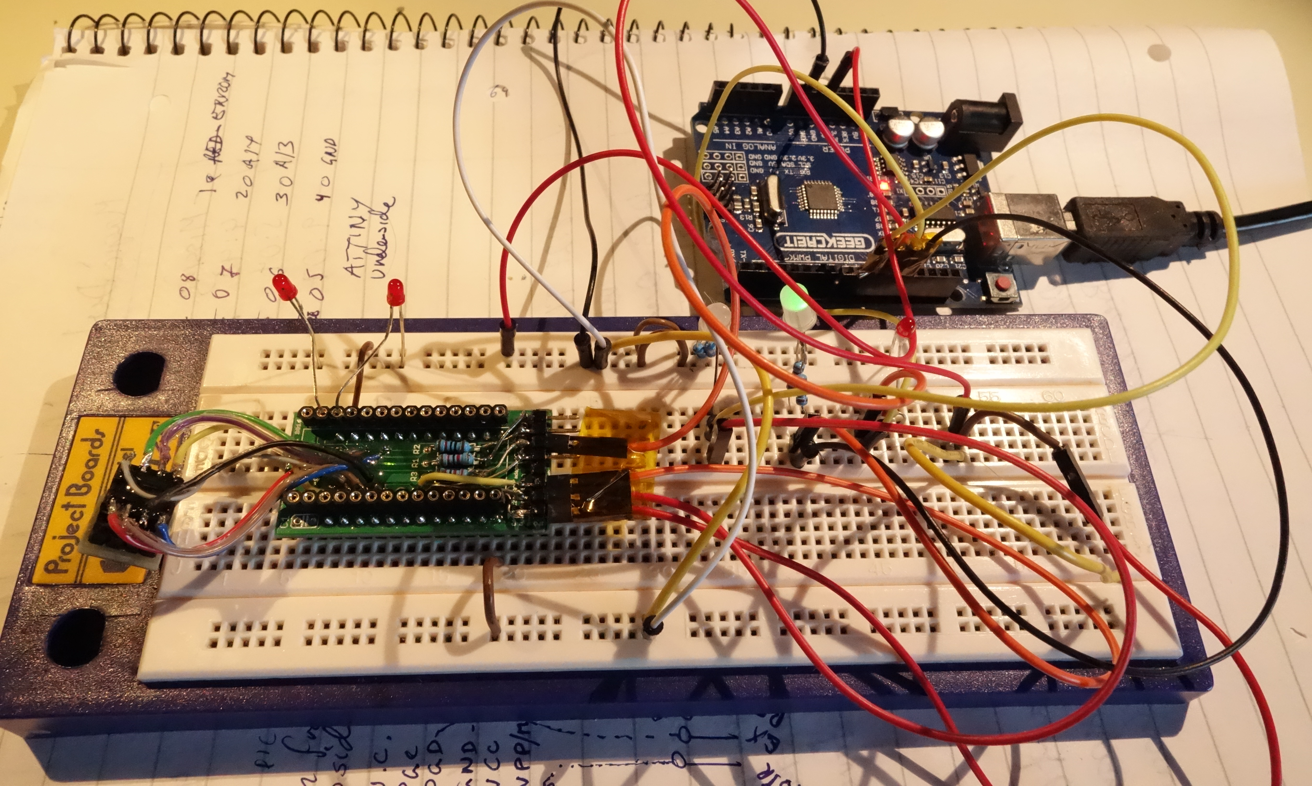
The two LEDs to the left are connected to A14 and A13. Those LEDs have internal resistors! The next two LEDs are connected such that they light up when EXROM or INTRST (C64 reset) go low. The anode goes to +5V through resistor, and the cathode goes to the I/O. Note: The SKS64 pins R, G and B are already current limited, but if you don't use an additional resistor, you will swamp the programming signals MISO, MOSI or SCK and Arduino IDE will just fail and say "MCU id 0x0000000" or "0xffffffff". Use a resistor. The RGB LEDs are incredibly sensitive and you can still get enough light even at 20k Ohm. Same for the RED Power LED. Finally attach a switch to GND, and to the RESTORE input. Now you have a development setup. Attach power, the USB cable, and you should be able to upload programs to the SKS64 without rearranging the cabling for each program iteration!

The RGB LED Cable Assembly
The current selected kernal ROM image is indicated with an RGB LED. RED, GREEN, BLUE and CYAN. It must ba a common cathode type*. Use the LED pinout diagram as shown below to locate the negative, red green and blue LED connections. Attach wires and use heat shrink tubing. You can see an excellent realization of this in the pictures below done by @thilographie_de . Thank you for letting me use your pictures.

The other end of the cable goes into a 2x3 female pin header. The connections for R, G and B in the PCB are noted on the silk-screen (the white text on the PCB). You can solder the wires directly onto the pcb if you like, but it is nice to be able to separate top enclosure where RGB LED is clipped into from the rest of the computer.

- A common cathode means that all cathodes are joined together. The cathode is the "negative" side of the LED. I bought it on eBay, and the product title was: "4PIN 5mm RGB LED - Tri-Colour 3 in 1 - Frosted Diffused Common Cathode".
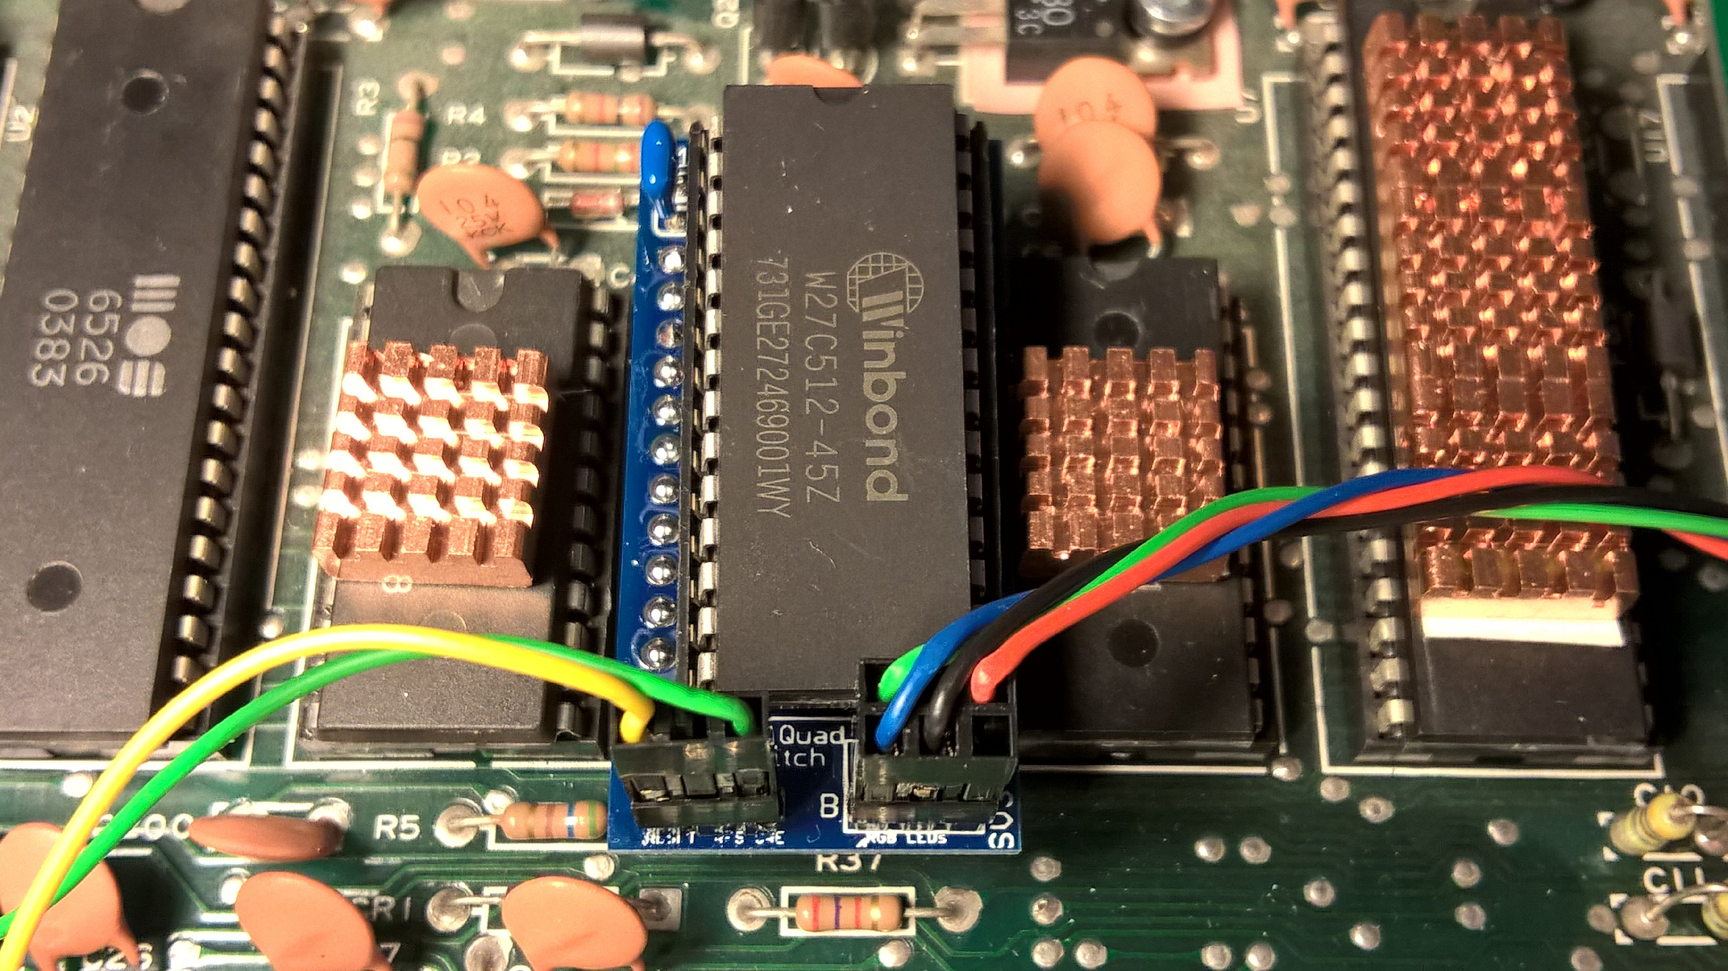
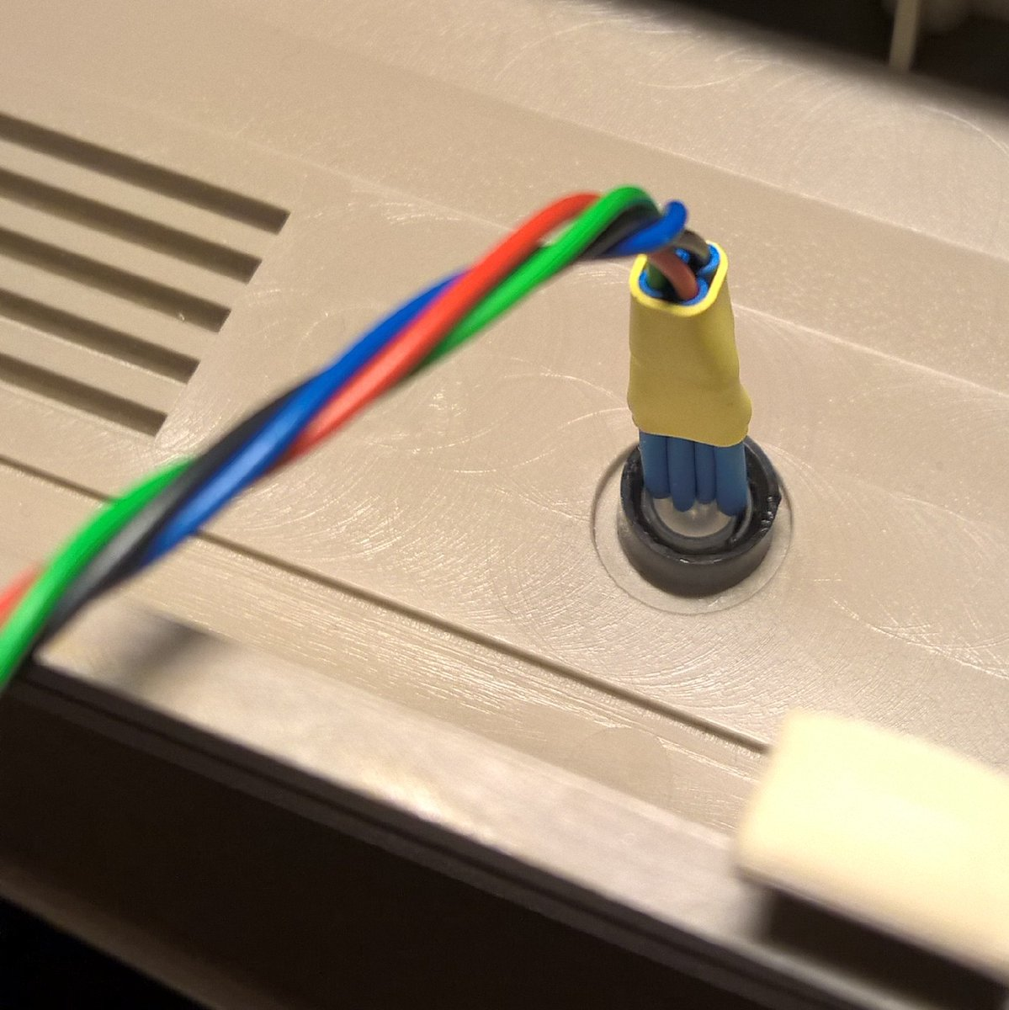
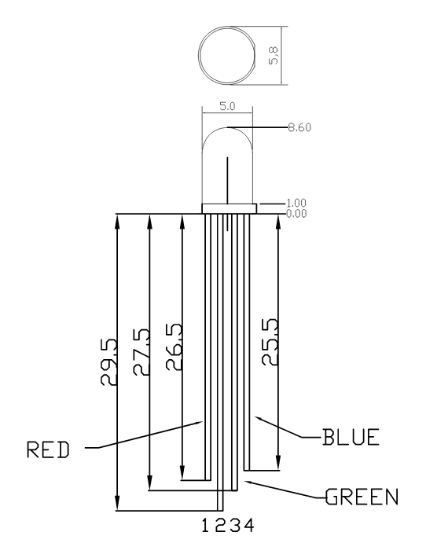
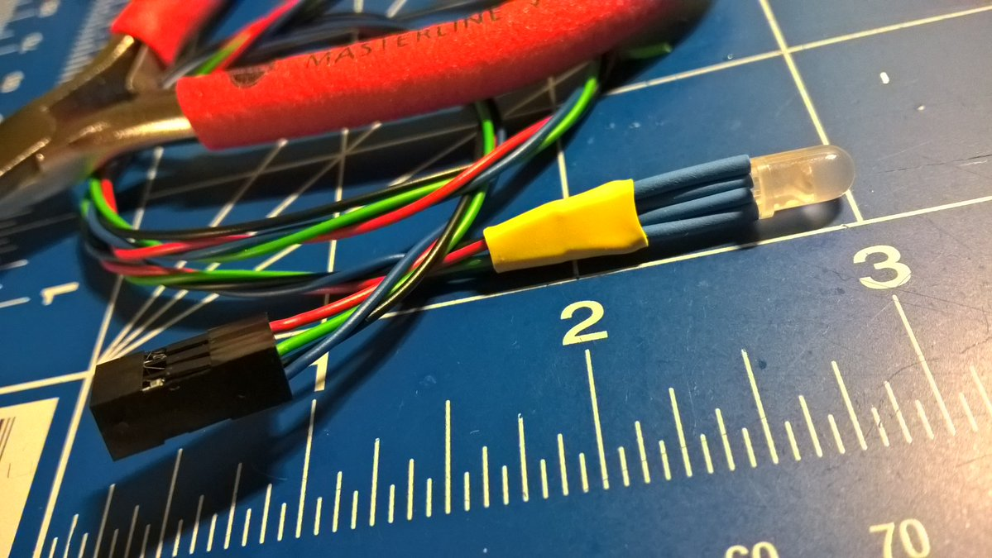

Schematics
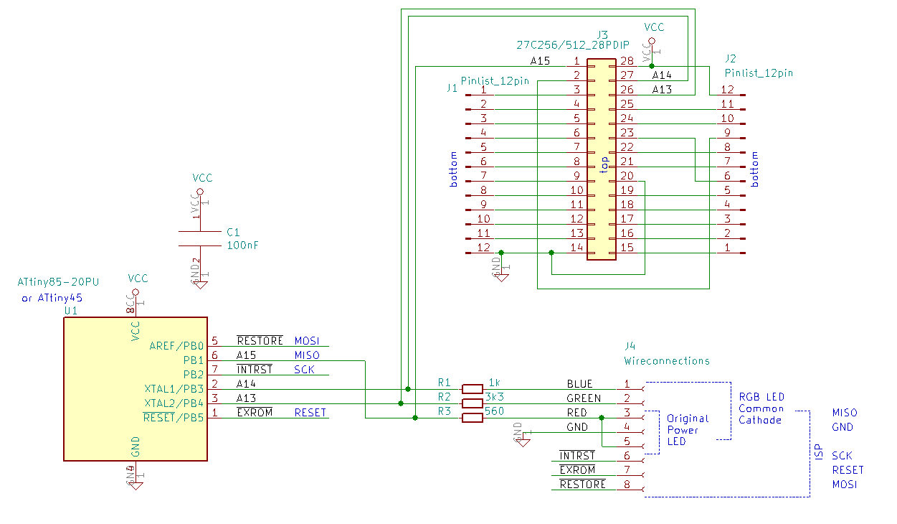
SKS64 longboard 1.21

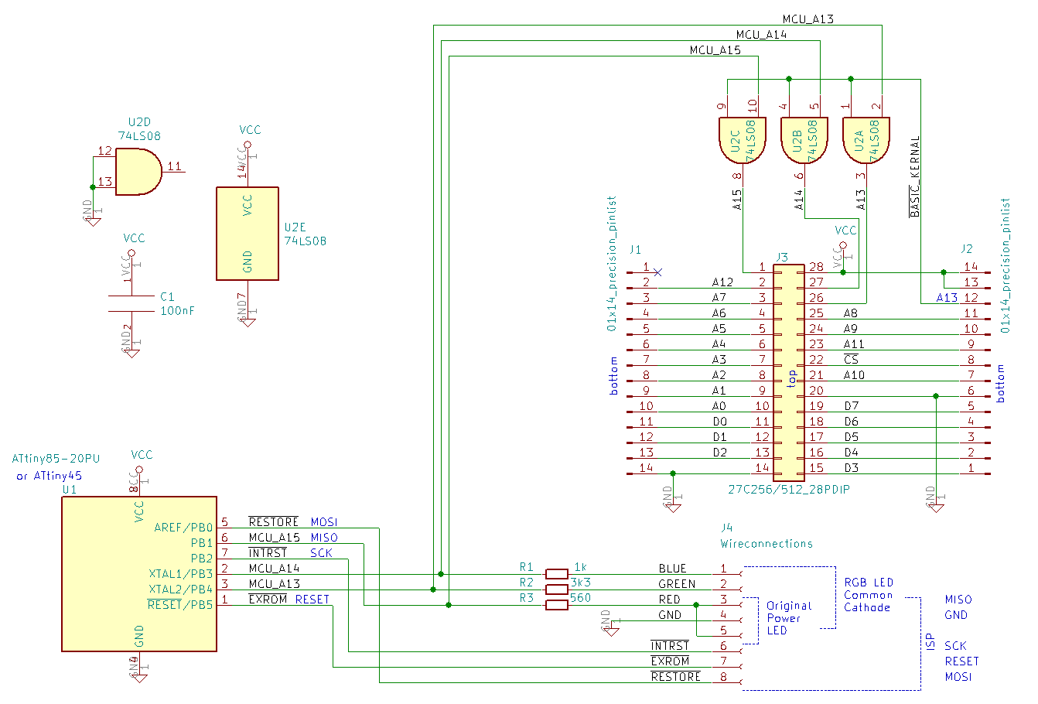
SKS64 shortboard 1.0

BOM
SKS64 longboard PCB:
Ref | Qty | Description / Value | Mouser No.
C1 | 1 | Cap THT DISC 3.9 W2.6 P2.50 | 594-K104M15X7RF53L2
J1 J2 | 2 | Pinlist precision turned male - 2.54mm 1x12 vertical | TS-112-T-A
J3 | 1 | IC Socket DIP-28 W15.24mm | 575-199628 (precision milled, round)  517-4828-6000-CP (dual wiper)  649-DILB28P223TLF (dual wiper)
J4 | 1 | Pin header 1x8 pin, P2.54mm, 0.635mm sq., 6.75mm, right angle | 538-90121-0768
R1 | 1 | Resistor 1k THT axial DIN0207 6.3 x 2.5 x 10.16mm | 603-MFR-25FRF521K
R2 | 1 | Resistor 3k3 THT axial DIN0207 6.3 x 2.5 x 10.16mm | 603-MFR-25FRF52-3K3
R3 | 1 | Resistor 560R THT axial DIN0207 6.3 x 2.5 x 10.16mm | 603-MFR-25FRF52-560R
U1 | 1 | Microcontroller Atmel ATtiny85-20PU PDIP | 556-ATTINY85-20PU
U1 | 1 | IC Socket DIP-8 W7.62mm | 571-1-2199298-2  110-47-308-41-001000 (mill-max)  110-87-308-41-001101 (preci-dip)
PCB | 1 | SKS64 longboard PCB | Order from JLCPCB, PCBWAY, or other.
For the motherboard: 2x SS-112-TT-2 or 575-199628 (not 24 pin!!!!) or 571-1-2199299-2 (not 24 pin!!)

SKS64 shortboard PCB:
MouserProject Link

Ref | Qty | Description / Value | Mouser No. | Elfa Distrelec
C1 | 1 | Capacitor Ceramic SMD 0805 | 80-C0805C104K1REAUTO | 300-86-638
J1 J2 | 2 | Pinlist precision turned male - 2.54mm 1x14 vertical | 200-TS114TA
J3 | 1 | IC Socket DIP-28 W15.24mm | 575-199628 (precision milled, round)  517-4828-6000-CP (dual wiper)  649-DILB28P223TLF (dual wiper) | 148-15-567
J4 | 1 | Pin header 1x8 pin, P2.54mm, 0.635mm sq., 6.75mm, right angle | 538-90121-0768
R1 | 1 | Resistor 1k SMD 0805 | 660-RK73B2ATTE102J | 300-56-717
R2 | 1 | Resistor 3k3 SMD 0805 | 660-RK73B2ATTDD332J | 300-56-883
R3 | 1 | Resistor 560R SMD 0805 | 660-RK73B2ATTDD561J | 300-56-898
U1 | 1 | Microcontroller Atmel ATtiny85-20PU PDIP | 556-ATTINY85-20PU | 173-25-159 (Attiny45!)
U1 | 1 | IC Socket DIP-8 W7.62mm | 571-1-2199298-2  110-47-308-41-001000 (mill-max)  110-87-308-41-001101 (preci-dip) | 148-15-561
U2 | 1 | 74LS08 SOIC-14 3.9x8.7mm P1.27mm | 595-SN74LS08DR | 173-90-123 (74HCT08)
PCB | 1 | SKS64 shortboard PCB | Order from JLCPCB, PCBWAY, ...

Wiring BOM

Ref | Qty | Description / Value | Mouser No.
1 | 1 | LED 5mm Diffused RGB Common Cathode | 604-WP154A4SUREQBFZW  743-HV-5RGB25 (clear)  743-HV-5RGB60  all these three alternatives have different pinouts.
2 | 6 | Molex Pre-Crimped Lead SL Female-to-SL Female, 300mm, 22 AWG | 538-79758-0011
3 | 1 | Molex SL Crimp Housing, Single Row, Version A, Non-polarized, 4 Circuits, Black | 538-50-57-9004
4 | 1 | Molex SL Crimp Housing, Single Row, Version A, Non-polarized, 3 Circuits, Black | 538-50-57-9003
5 | 1 | Heat Shrink Tubing and Sleeves 3/64", Black, Stick Price Per Foot | 650-RNF-100-3/640STK
6 | 1 | Heat Shrink Tubing and Sleeves 1/4 6IN 20PC BAG BLACK | 562-Q2Z14-6N20
7 | 1 | Headers & Wire Housings 3P AMPMODU II STIFT LEI (breakaway pinlist) | 571-826648-3

300 mm 24-30AWG dupont female-female

ATtiny library Installation instructions https://github.com/SpenceKonde/ATTinyCore

